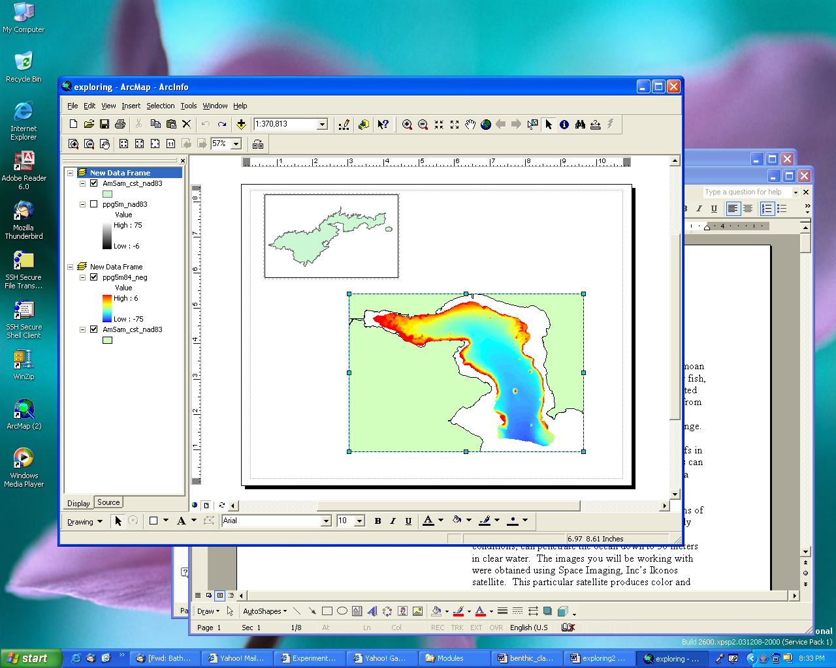

Note: Make sure you are saving where you intend! Check the folder in the top of the Save As dialog box. When naming raster files, the name can only be 13 characters long and it is never a good idea to have spaces in a filename.

Spatial and 3D Analysts
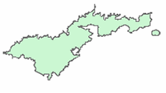
Introduction

Spatial Analyst is the tool ArcGIS uses to conduct analyses with raster data. 3D Analyst and ArcScene allow users to display and work with three-dimensional data. Although they are not truly 3D in that no three-dimensional calculations, such as volume, can be done on data, they are important tools for displaying data.

Objectives--By the end of this lesson, you should be able to:
- Create a new shapefile.
- Add data to a shapfile.
- Convert a bathymetry grid to a 3D display.
- Complete viewshed and hillshade analyses
- Select features with the attribute table
- Buffer a shapefile.
- Define: Viewshed and hillshade

1. Add the fb02_1m grid to the project.

2. Make sure the Spatial Analyst and the 3D Analyst Extensions are turned on.

a. Go to Tools→ Extensions.
b. Check the boxes next to Spatial Analyst and 3D Analyst.
c. To add the Spatial Analyst toolbar, go to View →Toolbar→Spatial Analyst.
d. Add the 3D Analyst Toolbar in the same manner.

- Make sure Spatial Analyst is turned on.
- Create a slope grid like you did in the previous lesson.
- Right click on the new grid and choose make permanent. Important: Save your grid in the same folder that contains the bathymetry grid.

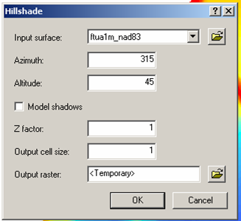
Figure 1

Azimuth is the direction from which the light is coming. North is 0° and, moving in a clockwise direction, the degrees increase. The most commonly used azimuth for mapping is 315, which would be northwest.

Altitude is the angle of the light source (sun) above the horizon. Forty-five degrees is the most commonly used altitude.
Hillshade: Hillshade analysis is a way to see where light would fall on a landscape. The resulting grid will appear as a grayscale (black & white) image. Hillshade often shows the landscape quite dramatically. Compare the hillshade grid to the original bathymetry grid.

- On the Spatial Analyst Toolbar, go to Spatial Analysis→Surface Analysis→Hillshade. This will bring up the Hillshade dialog box.

- Make sure the bathymetry grid is showing in the Input Surface field.

- For now, leave Azimuth and Altitude.

- Change the Output Cell Size to 1 and choose a filename the same way you did above for slope. Click Ok.

- Compare the Hillshade grid to the slope grid you made earlier.

  - What type of slope values appear in the areas that appear the steepest in the hillshade grid?
  - Try experimenting with several different Azimuth and Altitude values to see what happens when they are changed. What azimuth value makes the grid look inverted (i.e. ridges look like valleys)?

- When you have a hillshade that you like, click on the title of the bathymetry grid and drag it above the hillshade grid.

- Add the Effects toolbar in the same way you added the Spatial Analyst toolbar.

- In the Layer box on the Effects toolbar, make sure the bathymetry grid is showing. Click on the Transparency 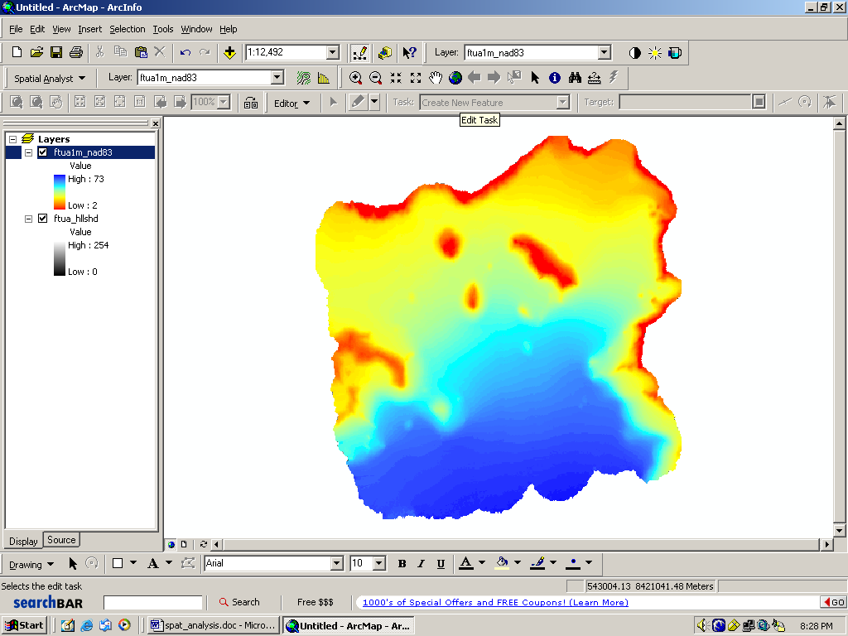button. This will bring up a slider bar: Set the transparency to something
Note: ArcCatalog is a program that allows you to manage your GIS data files. Since each shapefile and raster grid is actually a group of files, it is never a good idea to move or rename files in Windows Explorer. These types of things can be done in the same way in ArcCatalog and should always be done in ArcCatalog.
around 50%. The greater the percentage, the more transparent the layer.

9. Create a layout showing your hillshade with bathymetry over it. Remember to include a title, your name, a north arrow, a scale bar, and the date.

Creating and Editing a Theme

We need to create a new point shapefile.

- Open ArcCatalog.

- Go to File→New→ Shapefile. In the Create New Shapefile dialog box, change the name of the file to something meaningful. Make sure that Feature Type is Point and click Ok.

- Go back to ArcMap and add the shapefile you just created to your project. Make sure the Editor toolbar is visible. If not, add it.

- On the Editor Toolbar, go to Editor→Start Editing.
- Click on the Digitize Tool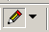. On the map, add points to the shapefile by clicking on the map. A colored point will appear. Add five or six points.

- Save your edits by going to Editor→Save Edits.

- Stop editing by going to Editor →Stop Editing

- You will use this shapefile later in the lab. Save your project and exit ArcMap.

3D Analyst

- Open ArcScene. Add the bathymetry layer the same way you would add a layer in ArcMap. Make sure 3D Analyst is turned on (see the instructions on page 1 for how to do this.

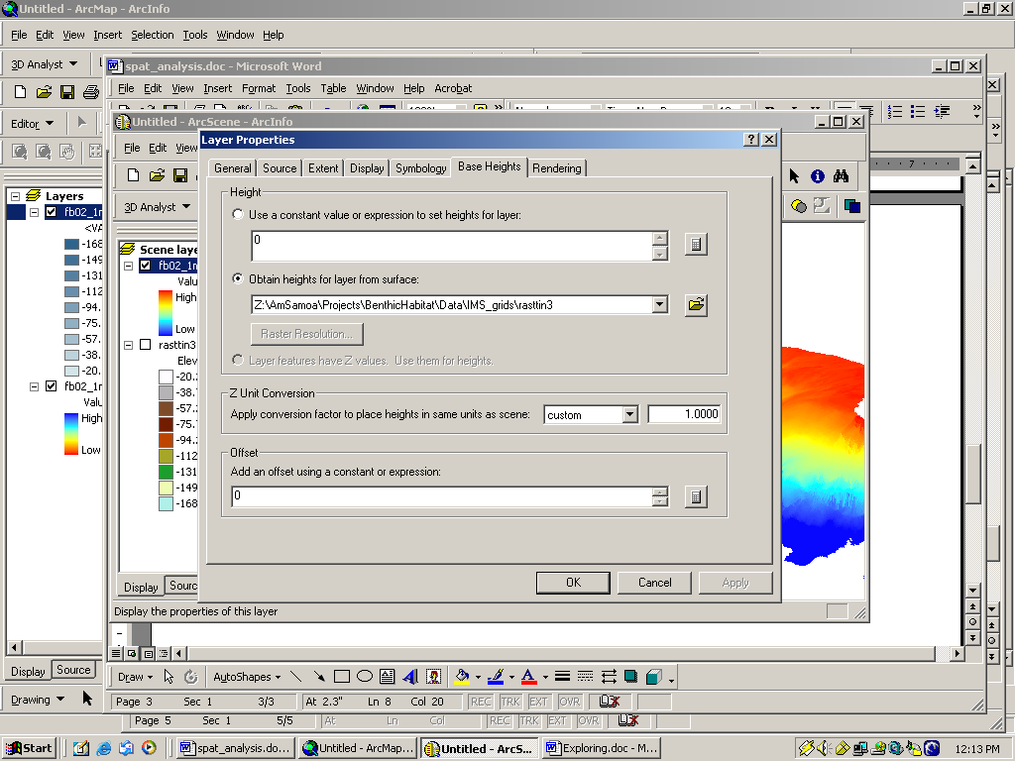
Figure 4
- In the 3D Analyst toolbar (if the toolbar is not showing, add it the same way you added the spatial analyst toolbar earlier), choose Convert-->Raster to TIN. The input file should be the bathymetry file. Choose a filename for the output file and make sure it is being saved in the correct location. Click Ok. Be patient, this will take a while.

- When the TIN appears, right-click on the bathymetry file and go to Properties. Click on the Base Heights tab. Click the Obtain heights for layer from surface option (Figure 4). Choose the TIN file you just created from the pulldown menu. Click Ok.

- Turn off the TIN layer. The bathymetry later should now be 3D.

Viewshed Analysis

A viewshed analysis shows you what can be seen from a point on a raster file. This analysis is commonly used to determine what can be seen from a given point in an area.

- Go to 3D Analyst→Surface Analysis→Viewshed. This will bring up the Viewshed dialog box.

- For Input Surface choose the bathymetry grid.
- For Observer Points choose the point shapefile you created on page 3.
- Change the Output Cell Size to 1.
- Choose a filename. Since the output viewshed file will be a raster file, remember, the name must be 13 characters or less.
- Click Ok.

- The viewshed file will appear in the layer list. It will be composed of two colors, one for visible areas and one for areas that would not be visible from the observer points. In other words, if you were diving at one of the points, the visible areas are the areas you could see from that point.

Figure 5

Note: You may have to rotate the image using 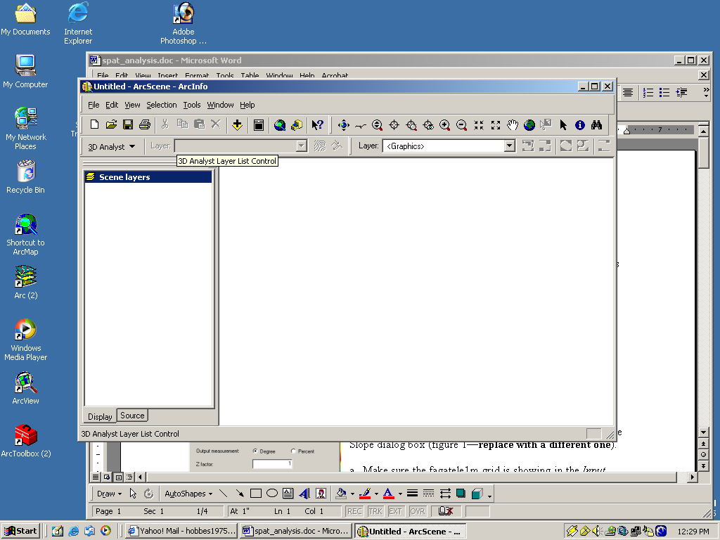 to make it appear correctly. ArcScene does not always draw things perfectly.

  - What types of applications can you see for a viewshed analysis, either land or sea-based?
  - What industries use viewshed analysis? You may have to search the internet to find this out. Be sure to say where you got your information.

- Add the hillshade file you created earlier in this lab. Make sure the viewshed file is first in the layer list and the hillshade file is second in the layer list.

- Turn off all other layers.

- Set the Base Heights for the viewshed to the TIN you created as described above.

- Set the Base Heights for the hillshade in the same manner. Before you click Ok, set an offset for the Hillshade of –10 in the Offset box of the Base Heights tab (Figure 5). Click Ok.

- Set the transparency of the viewshed file to somewhere around 50%. You may need to rotate the display to get it to display correctly.

- Do a screenshot of your viewshed file on top of the hillshade. To do this, press the Print Screen (PrtScrn) button on the keyboard. Open Microsoft Word with a new document. Either do a Ctrl-->V or go to Edit-->Paste and your image will appear.

- Save your project.

MPA Designation

Designating Marine Protected Areas (MPAs) can be difficult. It is important that the place chosen to be an MPA protect as many species as possible, often in the smallest possible area. Not only must you determine where the best location is for an MPA, you have to work with the people who would be affected by a marine reserve to make sure they, at the very least, do not oppose the MPA. There are two kinds of MPAs in American Samoa: no-take MPAs and MPAs where limited fishing is still allowed. The only no-take MPA in American Samoa is Rose Atoll National Wildlife Sanctuary.

Fagaitua Bay

- How many federal MPAs are in American Samoa?

- What types of fishing are allowed in Fagatele Bay National Marine Sanctuary and National Park of American Samoa (http://www.fbnms.nos.noaa.gov/ and http://www.nps.gov/npsa/home.htm/)?

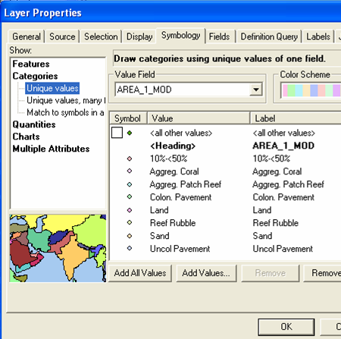
- Add ftuaneg1m and ftua_ptsfinal, to your project. Make sure they are all visible.
Figure 6

  - Zoom to Fagaitua Bay (see map at left).

  - Go to Properties and click on the Symbology tab. Change how the layer is displayed by clicking on Categories and then Unique Values (Figure 6).

    - In the Value Field pulldown menu, choose AREA_1_MOD.
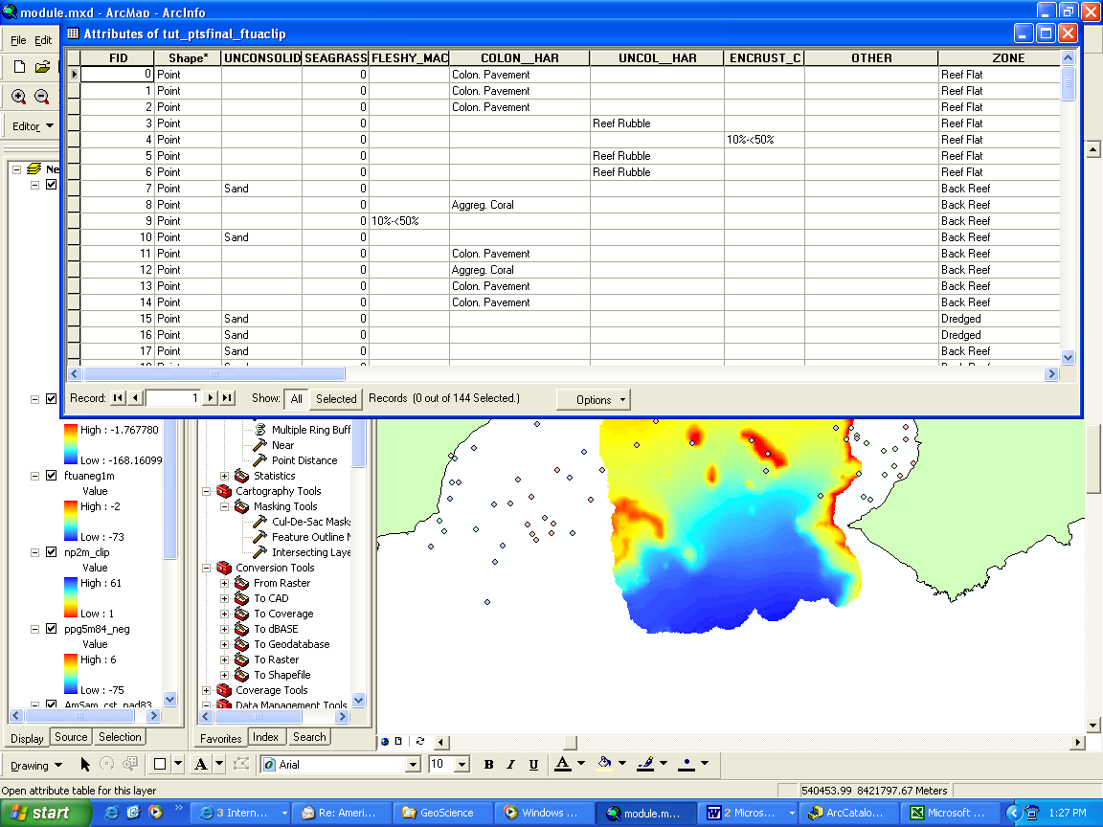
    - Click the Add All Values button. If the color scheme is something you like, click Ok. Otherwise, choose a different color scheme and click ok.
Figure 7

  - Use the Identify tool and click on several points.

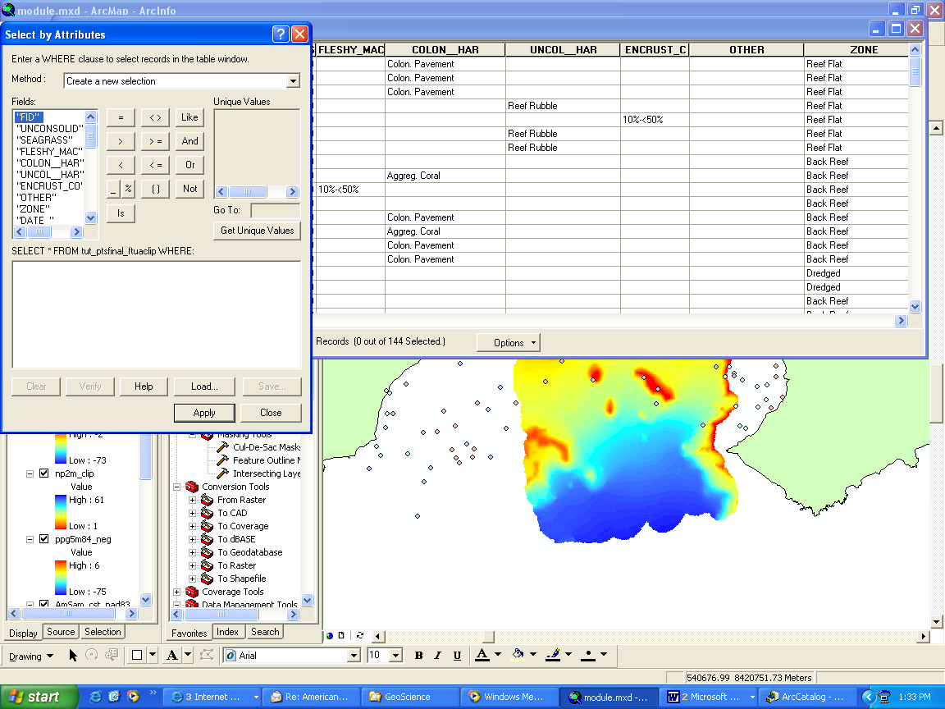
- Open the Attribute Table for ftua_ptsfinal. Right-click on the name of the file and choose Open Attribute Table.
Figure 8

  - Click on the Options→ Select By Attribute (Figure 7). This will bring up the Select By Attributes Window (Figure 8).
  - Under Fields, double-click on “AREA_1_MOD”
  - Click the = button
  - Click the Get Unique Values button.
  - Under Unique Values, double-click on ‘Aggreg. Coral’

Note: Click the Select button to see only the records that have been selected. To see all of the records again, click the All button.

Note: A Buffer Analysis defines an area around a feature of interest, in this case, coral. In this case, the buffered area around the coral can help identify an area that would provide protection for coral and reef fish.

  - In the Select From…box, it should look like this:
"AREA_1_MOD" = 'Aggreg. Coral'
  - Click Apply.
  - Close the Select By Attributes window.
  - Look at the Attribute Table.
  - Look at the map, the points that are highlighted are those that you selected in the attribute table.
  - Go to Options→Clear Selection.

- Now you will find out where most of the coral in Fagaitua Bay is located. To do that, you will have to select points based on more than one Unique Value using the OR connector.

  - Follow steps 5 a-f above.
  - Click the OR button.
  - Repeat step 6a, but this time, instead of choosing ‘Aggreg. Coral’ for the Unique Value, choose ‘Colon. Pavement’.
  - Click the OR button.
  - Repeat steps 6c and 6d for the following Unique Values: Indivd. Patch Reef, Aggreg. Patch Reef, Colon. Pavement, and Scat. Coral/Rock.
  - Click Apply.
  - Close the Select by Attributes window.
  - In the Attribute Table, some records will be highlighted. If you just want to see the selected records, click the Selected button. If you want to see all of the records again, click the All button.
  - On the map, all of the selected points will be highlighted.
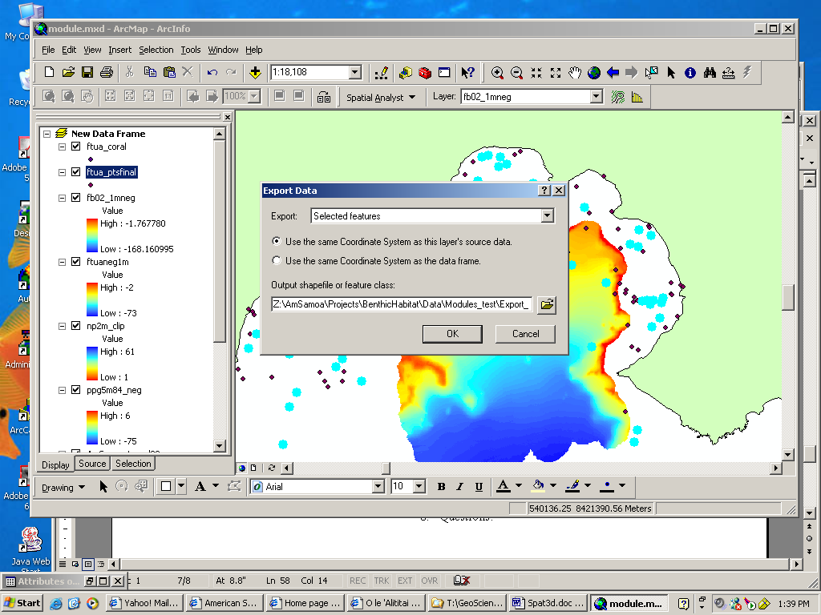
  - Make a layout showing the selected points.
Figure 9

- Now we are going to buffer around the coral points to determine the best place for an imaginary marine protected area.
  - Right-click on the ftua_ptsfinal in the layer list. Choose Data→Export Data. Make sure Selected Features is showing in the Export pull-down menu. In the Output box, name your file ftua_coral (Figure 9).
  - Turn off the ftua_ptsfinal layer.

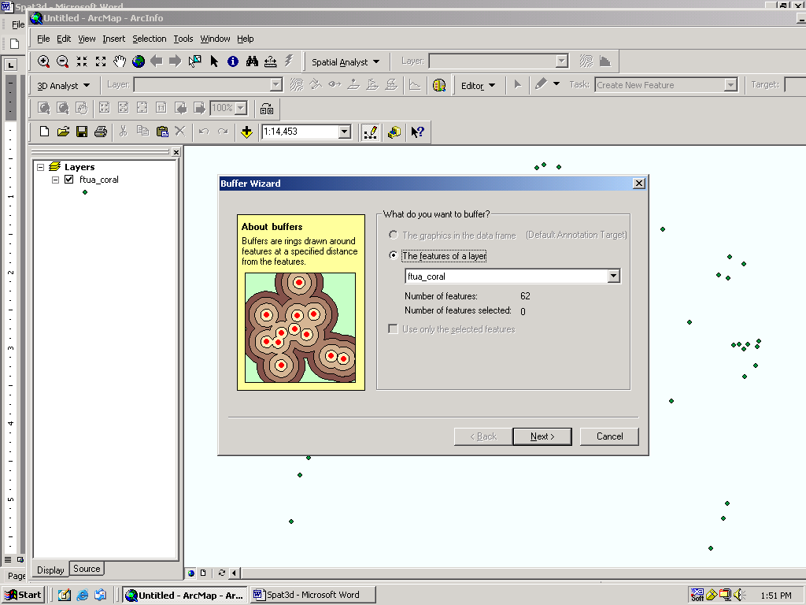
Figure 10
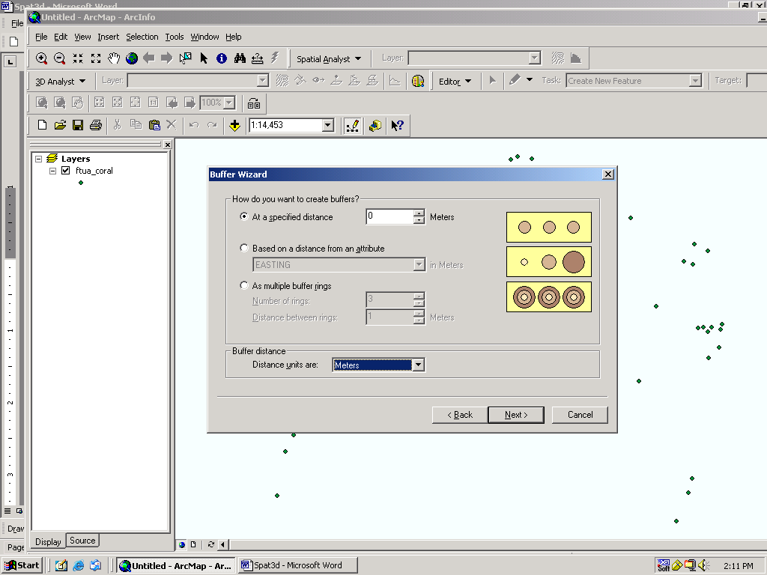
Figure 11
- Go to Tools→Buffer Wizard.
- Choose The Features of a Layer and make sure ftua_coral is showing in the pull-down menu (Figure 10). Click Next.
- Change the Buffer Units to Meters.
- We want to create a 100 meter buffer around the coral, so type 100 in the box after At a Specified Distance (Figure 11). Click Next.
- Make sure that Yes is checked under Dissolve Barriers. Click Finish.

- Now you need to decide where to designate an MPA.
  - Some things to keep in mind:
    - An MPA should be efficient: It should protect as much as possible while placing restrictions on as little area as possible.
    - Many MPAs prohibit all fishing and collection, while others allow some types of fishing and collection.
    - You will have to get people affected by the MPA rules to agree to them.
    - An MPA that only protects shallow areas may not protect fish that spend part of their time in deep water.
  - Make a layout showing the buffered areas and draw where you will create an MPA. Keep in mind this is an imaginary MPA, but you will have to come up with a strategy to sell it to people who fish there.

- Questions:
  - How many points are classified as Aggregate Coral?
  - How many total points have coral (step 6)?
  - What areas of the bay have the densest clustering of coral?

- Write a brief proposal (3-5 pages) with maps about your MPA. You will need to include maps of where the coral is located, where you propose to locate an MPA and what villages are affected (you may want to use tut_villages). Be sure to answer the following questions in the proposal:

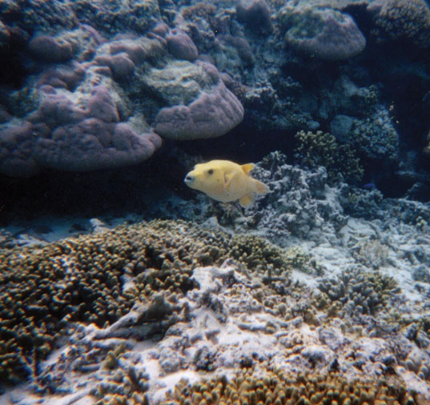
  - List four species of reef fish people eat in American Samoa. If you know the English name, find out the Samoan name. If you know the Samoan name, find out the English name. Use the National Park of American Samoa Fish Inventory for help with names (http://www.nps.gov/npsa/NPSAfish/).

  - What kinds of fish might be protected by protecting coral? Use the Natural History Guide to American Samoa (http://www.nps.gov/npsa/book/index.htm) for more information. Be sure to cite your sources.

  - Why did you choose to protect the area you did?
  - Who would be affected by prohibiting all fishing in Fagaitua Bay?

  - Which villages would you have to work with to create an MPA in Fagaitua Bay?

  - How would you convince these villages to agree to a fishing ban? Outline a strategy for talking to villages, including who you would ask for help.

  - What kinds of maps and information would you use to convince village leaders that an MPA is necessary in their area? Be sure to include these in the proposal.

  - If you were going to allow some kinds of fishing, what kinds would you allow?

  - What regulations will your MPA have?

  - How will you enforce the regulations?

  - If it was impossible to establish an MPA in Fagaitua Bay, where would be a good alternative?
What to Turn In

1. Answers to questions on pages 2, 5, 6and 8.

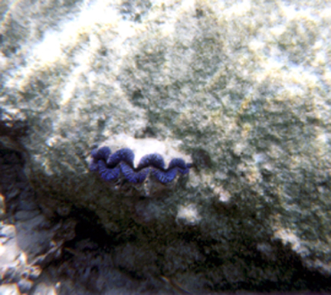
2. A layout showing the hillshade overlain by bathymetry.

3. An image showing the viewshed file on top of the hillshade from ArcScene.

5. A layout showing the points with coral.

6. Your MPA proposal.

